INTRODUCTION TO CLOUD COMPUTING

12784 Generative AI

### 

### Group Members

**Komal Kumar Penti (700753835)**

**Rohan Akshintla**

**Sai Vardhan Reddy Gummadisani**

**Bharath Kumar Somarathi**

**Online Car Sale**

# **Project Description:**

The online car sale project website is a comprehensive website for selling cars .This website allows customers to search the cars and view all car details about each car such as specifications and features. The owner can easily establish a listing by entering vital information and adding images. And the website also has advanced search criteria , which helps consumers identify the cars that fit their individual needs and tastes. The website also offers secure payment processing and customer authentication transactions are safe and secure. By including these elements the online car sale website streamlines the purchasing and selling procedure, making it more. And also The website all data will be stored securely in a database.

In our website we have three modules:

1. Admin
2. Car owner
3. Customer

In this website the admin will have predefined login credentials like username and password to login into this website.

After login admin can add locations and view locations. The car owner can register into this website with basic information like name, phone number, email,password address etc. After registration the admin can view and verify the car owners. After the verification the car owners can login into this website with a registered email and password. The car owner can add the car details on this website and also the car owner can view the added cars. The admin can view the cars which are added by the owner and verify the cars. The verified cars are only viewed by the customer.

The customer can register into this website with details like name, phone number, email, password and address etc. The customer can login into this website with a registered email and password. The customer can view the cars and search the cars and choose one of the cars and send a request to the car owner to buy the car. If the customer wants to cancel the request they are able to cancel. All requested cars can be viewed by the car owner and admin on the website.

Here if a customer wants to chat with a car owner the customer can chat with the car owner regarding car details and car transportation. The car owner will dispatch the order after the status will be changed to make payment to the customer module. The customer will make the payment and receive the car. and the 10 % of payment will be transferred to the admin. The whole history can be viewed by the admin and the car owner and also customers on the website

**Technologies:**

**Frontend:** HTML, CSS, JAVA SCRIPT, BOOTSTRAP

**Backend:** PYTHON , Flask

**Database:** MYSQL.

# 

# 

# **AWS** SERVICES :

## **VPC(Virtual Private Cloud):**

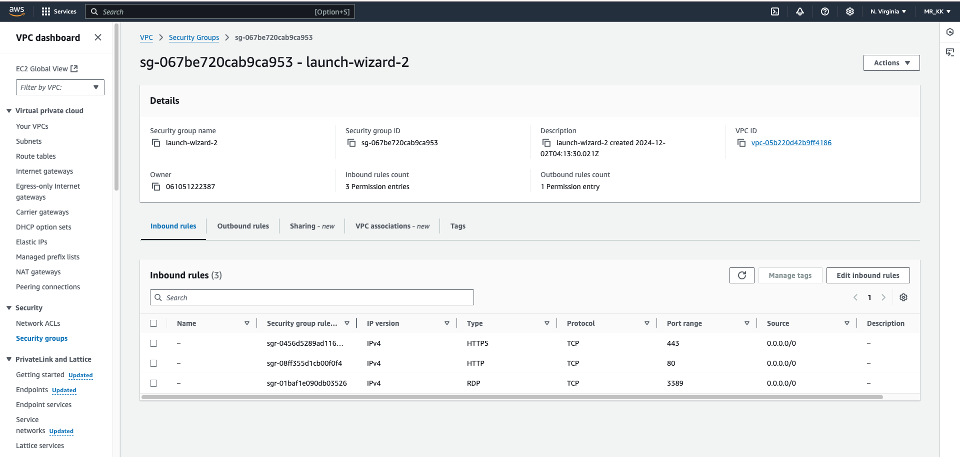

The amazon accounts are the only ways to access this virtual network. We can start an EC2 instance with VPC`s improving network resource management and security. Amazon VPC enables you to build a virtual network in the aws cloud. We can host the necessary resources and manage access to those resources in the VPC, a private area of amazon that we access or control.

## **RDS(Relational Database System):**

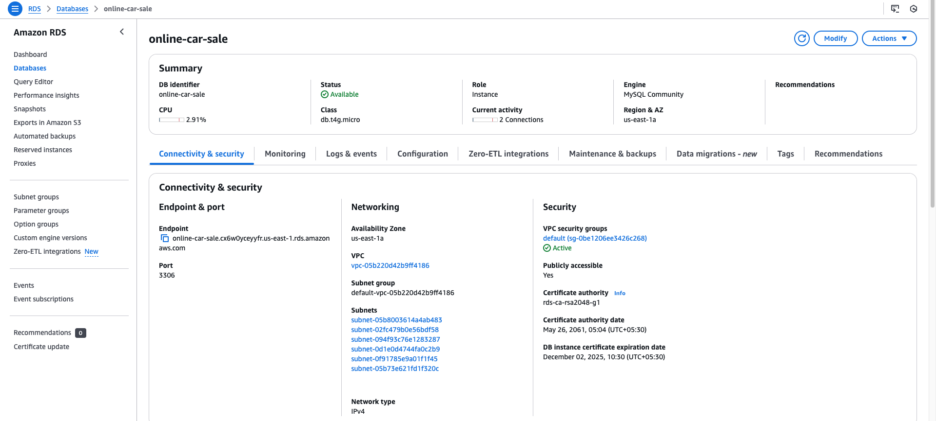

Aws Relational Database System(RDS) is one of the major services. RDS is a fully managed database service that provides MYSQL databases for easy application interaction. By revealing developers of database management responsibilities, RDS improves efficiency and productivity by freeing up developer time for application development. Amazon RDS keeps our database software secure and up-to-date, automatically.

## **EC2(Eclectic Compute Cloud):**

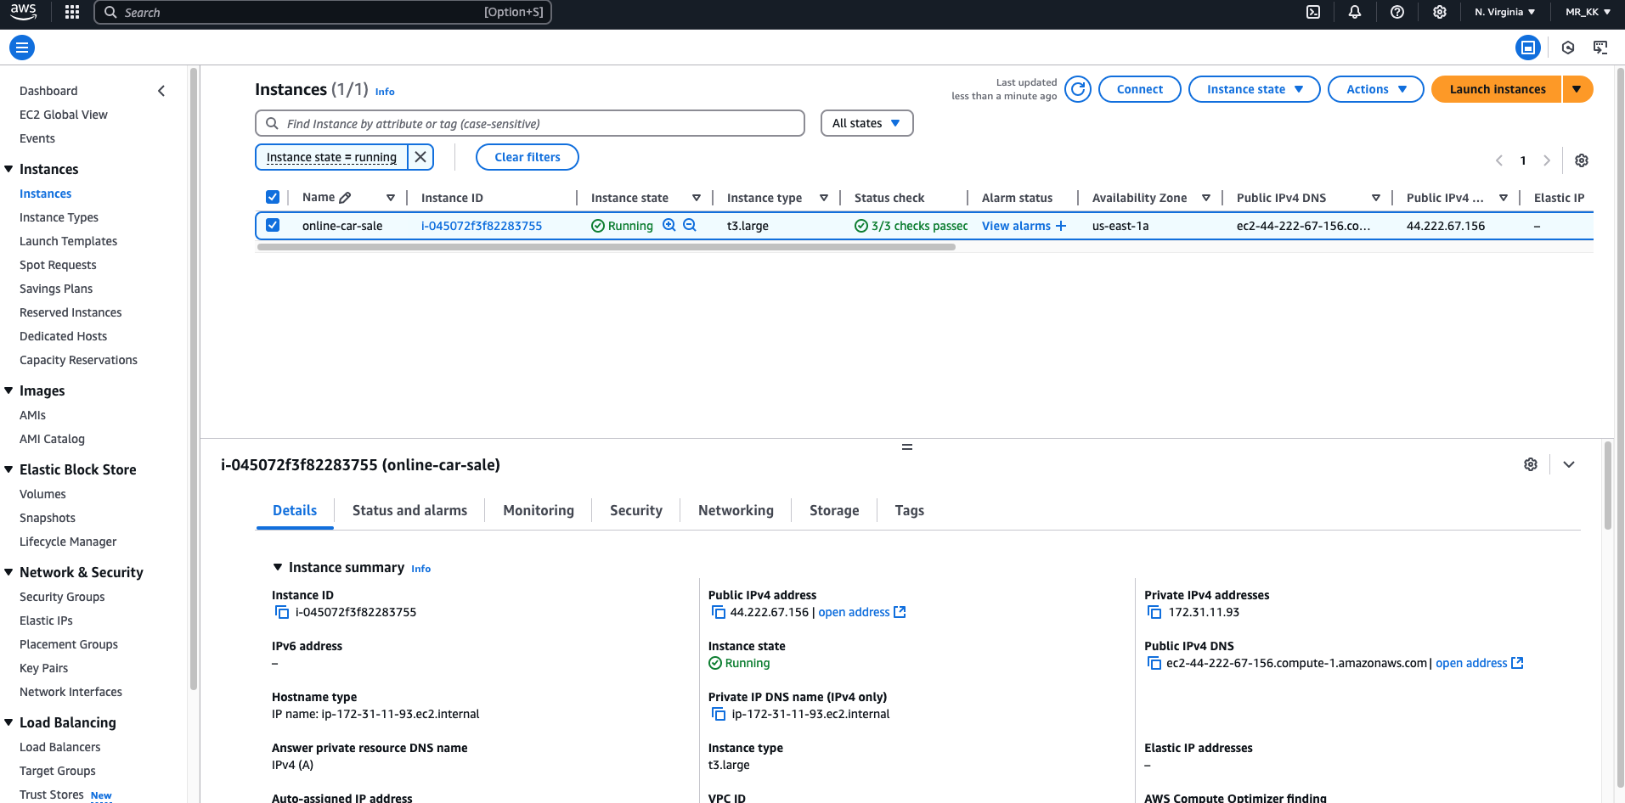

In Aws amazon Ec2, a cloud computing platform provides a secure and processing environment. It is used for remote desktop applications to establish a connection between amazon EC2 instances produced from most. Windows Amazon Machinery Images(AIMs). Since you have been added to the aws directory service, use the administrator's username and password while using the desktop. Where in this EC2 instance we host our website. By using an EC2 instance we can easily host our application in a virtual environment, and using the public and private key we access our application globally.

## **SES(Simple Email Service):**

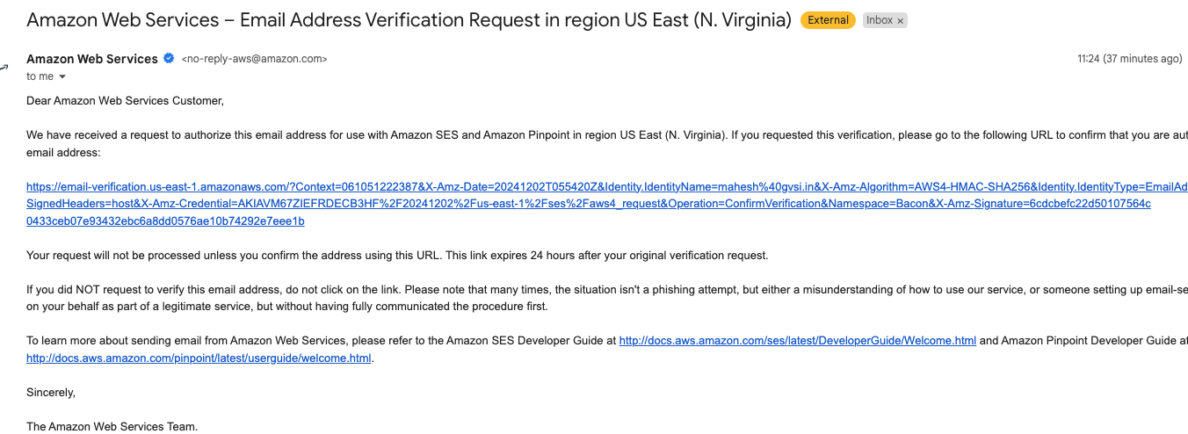

In Aws users must first register for an AWS account in order to access SES. After registering individuals can use SES to create authenticated identities, which enables email sending and receiving. Users may easily create and maintain email addresses with SES`s dependable and scalable email communication management platform. Websites can use SES to integrate a contact verification process, guaranteeing safe and approved access to email features. SES can perform various tasks based on the user requirements.

## **S3 (Simple Storage Service)**

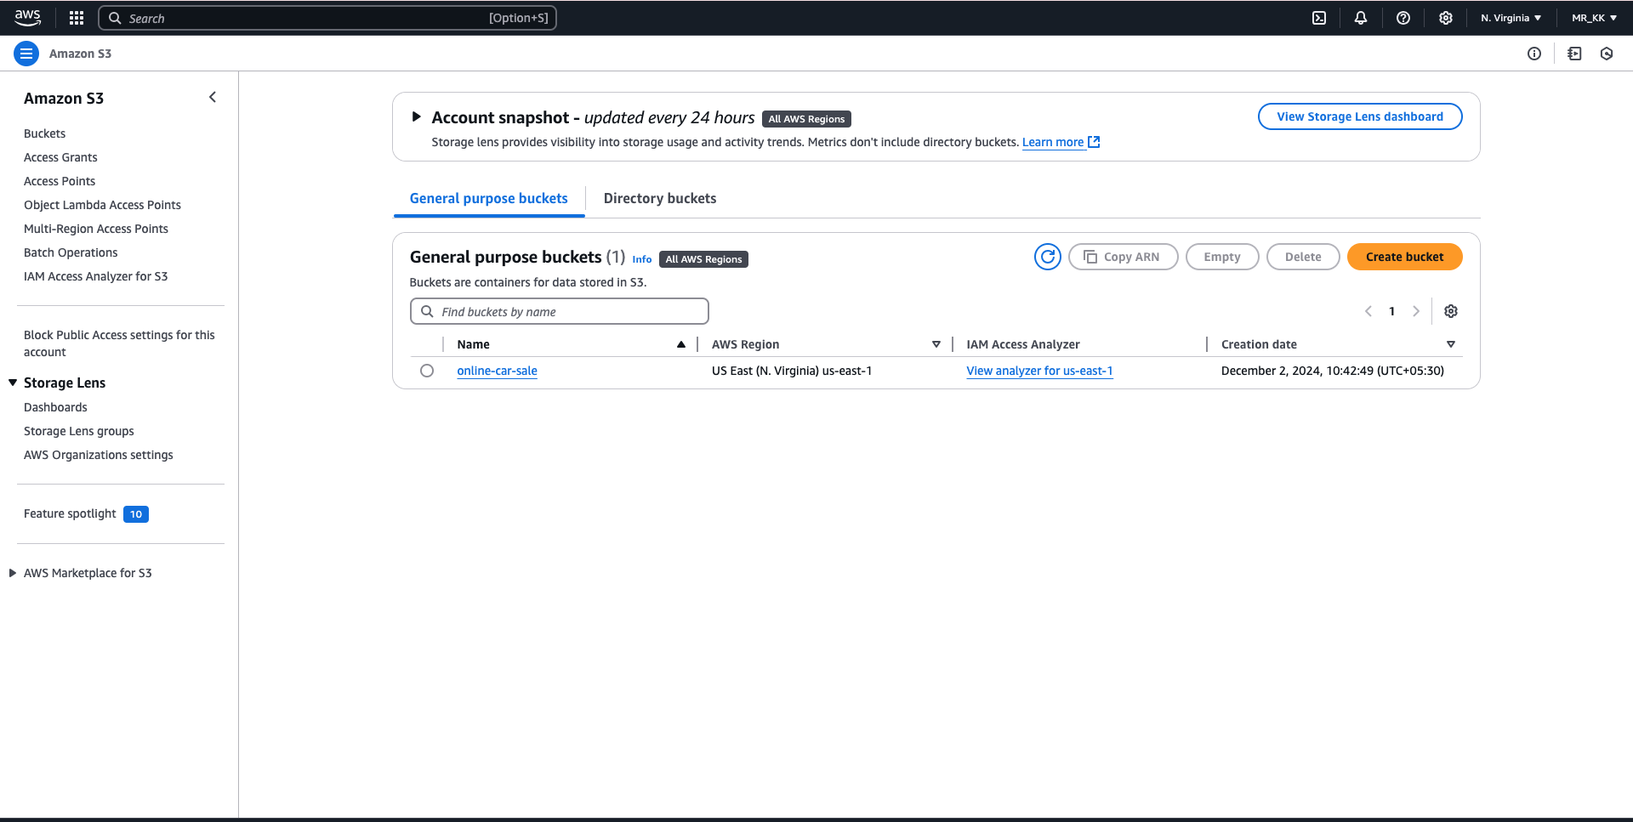

Aws S3 bucket is a Simple Storage Service, users can safely upload a variety of file types, including documents and images to the Amazon S3 bucket after it has been created. The bucket facilitates easy access to and management of uploaded files by acting as a central repository inside an amazon region.In amazon AWS contains the multiple reasons to provide the services to users. Furthermore, users can manage who has access to view, download and alter the stored files by configuring permissions and access controls.

## **IAM User:**

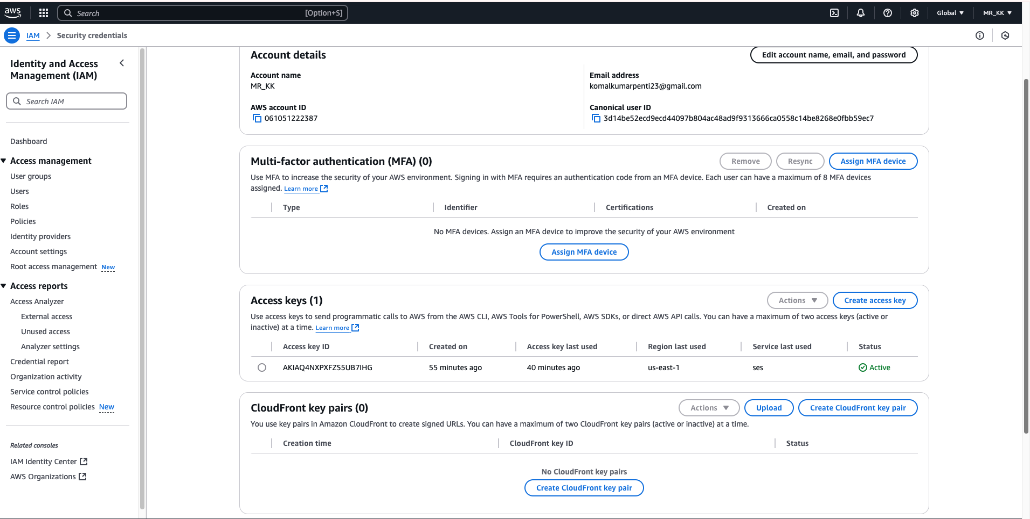



In Aws when the aws users are trying to access AWS service, AWS identity and Access Management(IAM) act as the gatekeeper. Access keys and secret access keys are provided to these IAM users, enabling secure authentication for S3 and SES interaction with AWS services. Iam User accounts, which are configured with particular permissions and policies, serve as the representation of users with IAm.

**Web Pages :**

**Home Page:**



This is the home page of this car sale website. Here we have three modules: admin, owner and customer.

**Admin Login Page :**

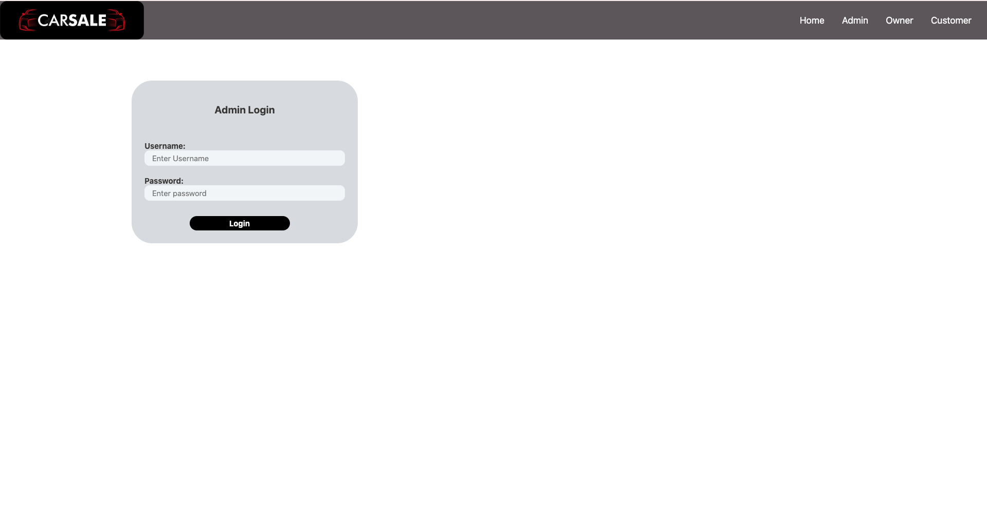

The admin will login in to the website with default login credentials like user name and password by clicking on the login button the page will be redirected into the admin home page.

**Car owner Registration Page:**

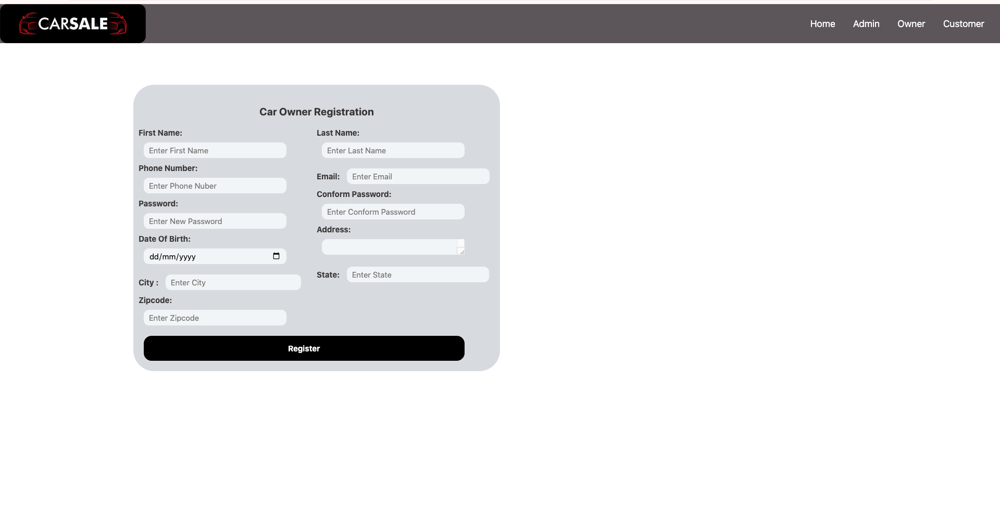

This is the car owner registration page . The car owner can register into the website by entering the above details and by clicking on the registered button the car owner will be registered.

**Car owner Login Page:**

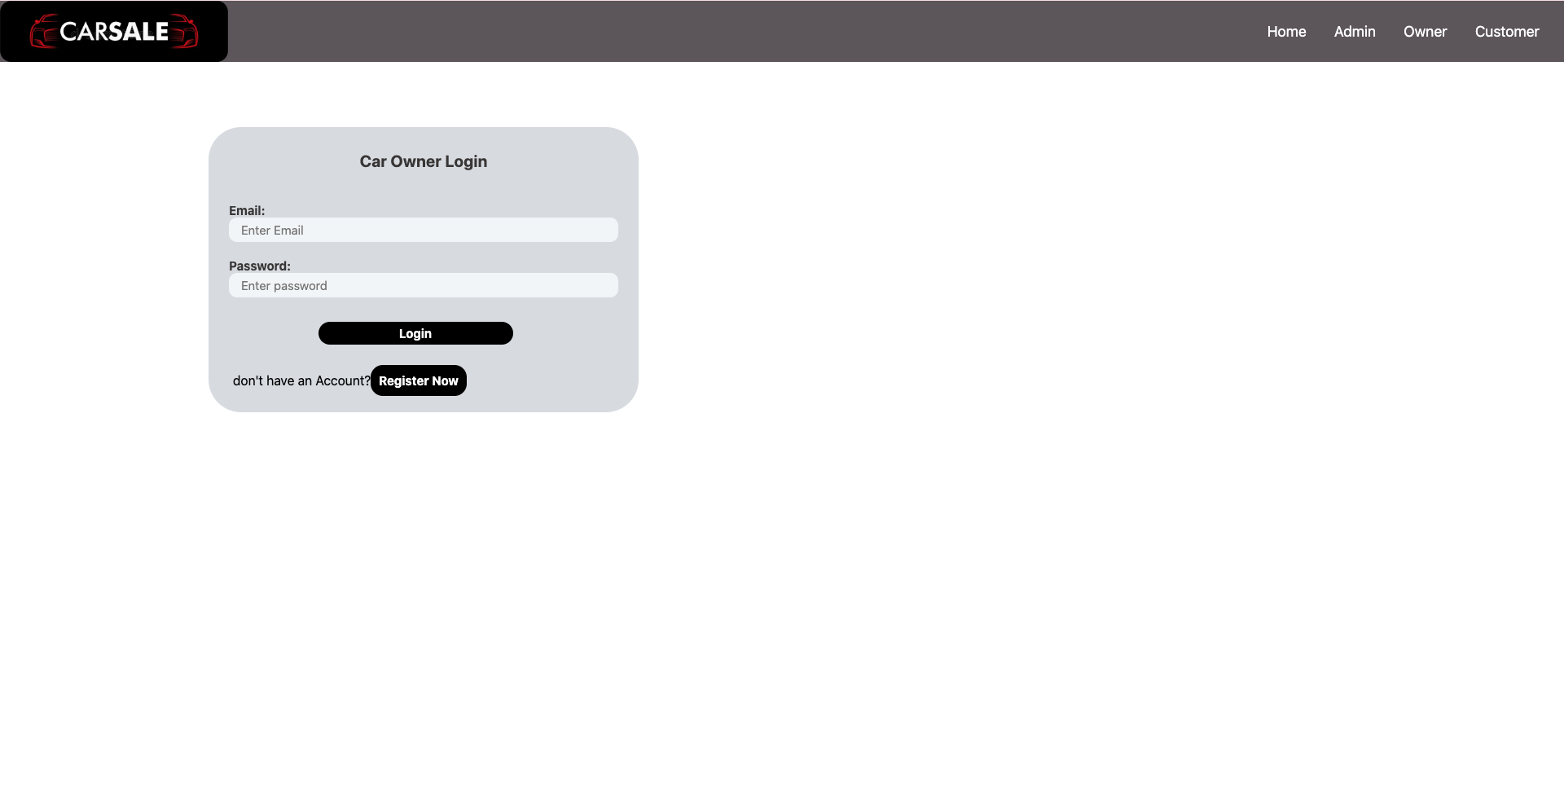

This is the car owner login page. The car owner can login into the website with a registered email and password .

**Customer Registration Page :**

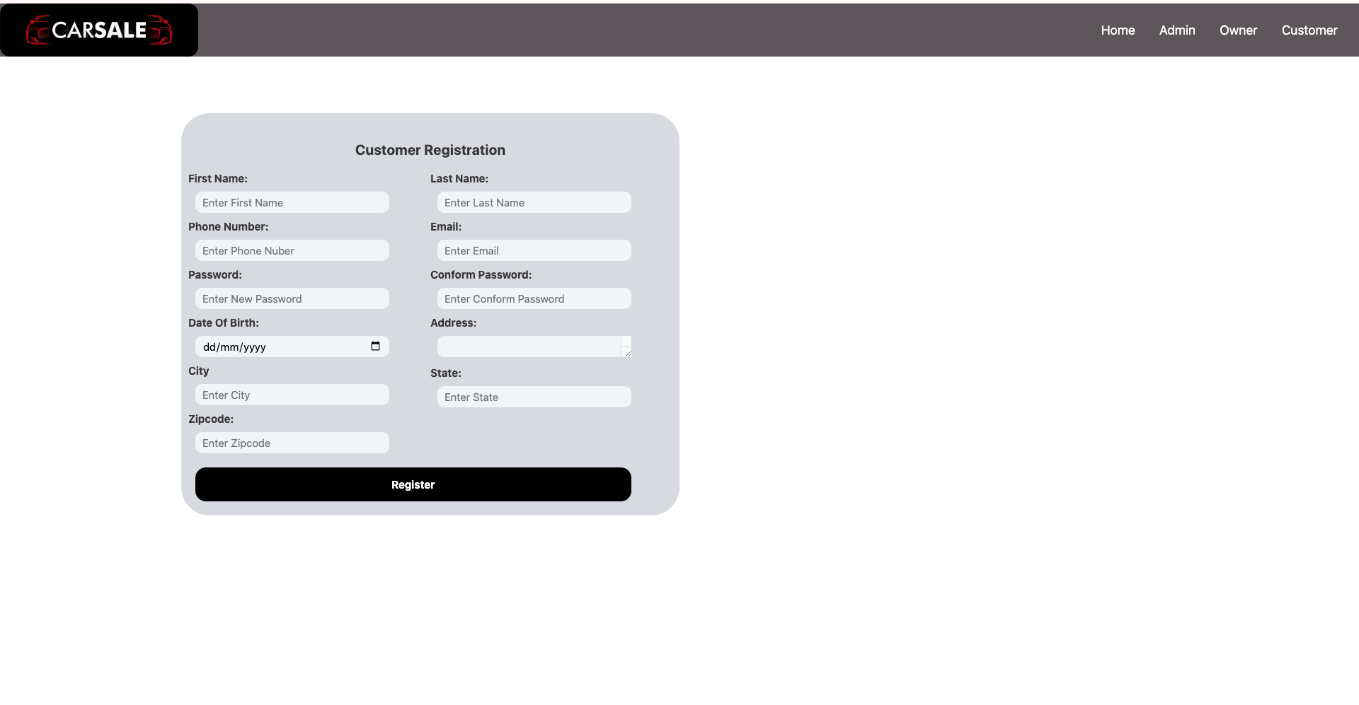

This is the customer registration page . The customer can register into the website by entering the above details and by clicking on the registered button the customer will be registered.

**Customer Login Page:**

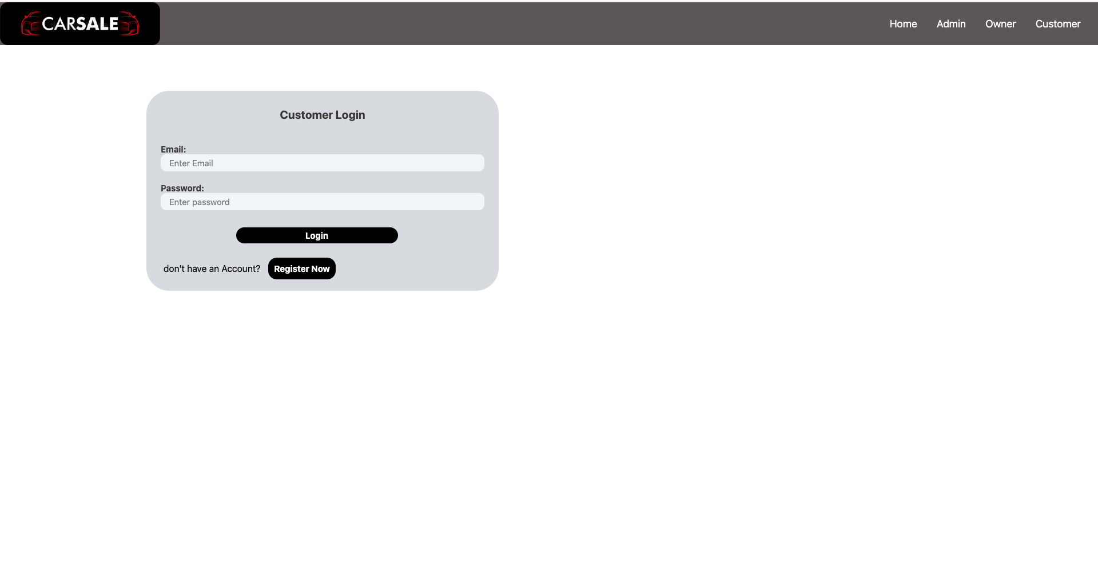

This is the customer login page. The customer can login into the website with a registered email and password .

**Car owner add / view cars :**

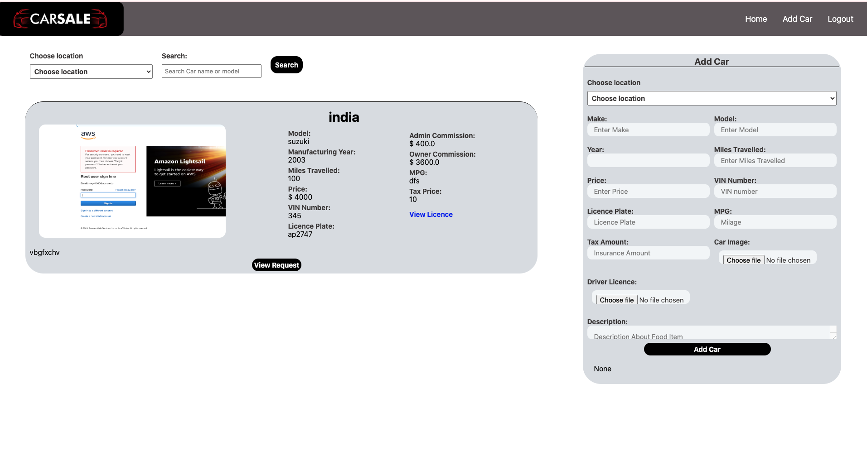

This is the car owner add and view car page. In this the car owner will add the car by entering the above details and clicking on the add car page the car will be added. And also the car owner can view the added can in the same page with details. By clicking on the view request button the page will be redirected into the customer requests.

**Customers view the requested car.**

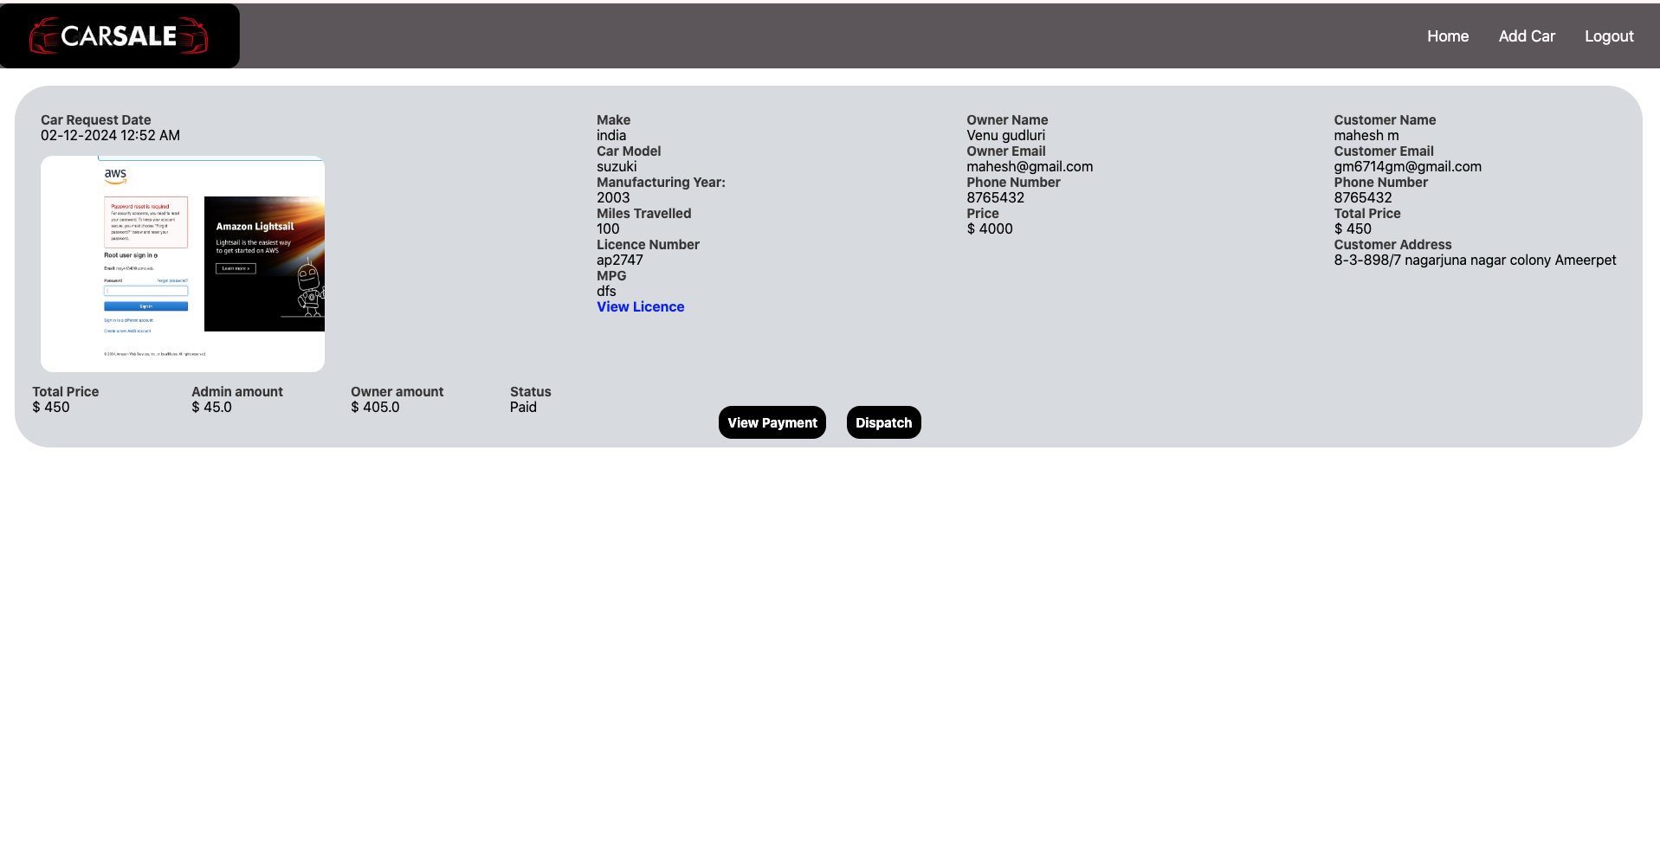

The customer can view the status of the car request and if the car owner accepts it then the customer can pay the amount and buy the car.

**View orders :**

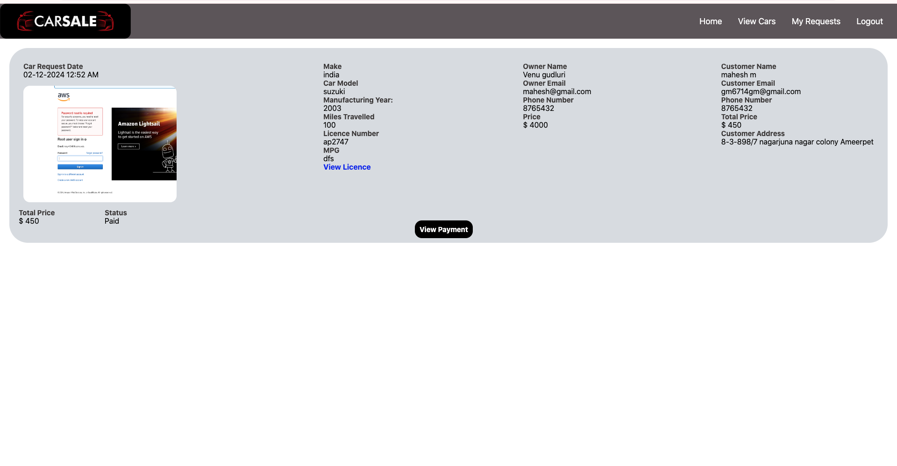

The customer can view the history of ordered cars in my request page , and clicking on the payment page the transactions will be viewed.